Order Of Service

Singing: Psalm 91—CW page 100

Reading: Psalm 44

Opening Hymn: CW 617

Reading: Acts 2:29-42

Request Hymn: CW Supplement 769

Reading: John 10:31-42

Sermon Hymn: CW 618

Sermon Text: Song Of Solomon 7:5

Mount Carmel

Prayer

The Apostles’ Creed, TLH page 12

Holy Communion

The Lord's Prayer

The Blessing

Closing Hymn: CW 619

* * * * * * * * * * *

Koinonia Hour

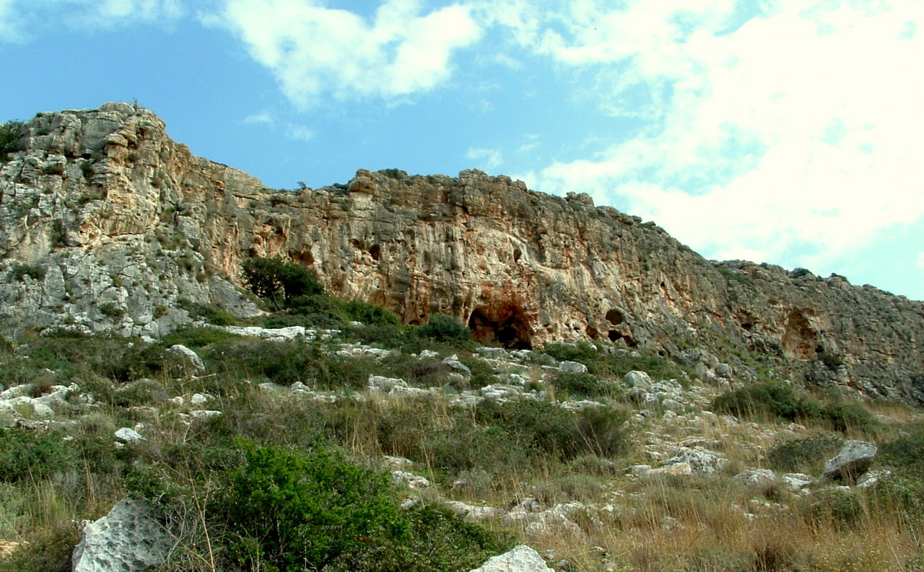

Mount Carmel

Water
Of
Life

2 July 2017

W A T E R O F L I F E

Independent Christian Church—Conservative Lutheran Doctrine

Worship Service: 9:30 a.m. Bible Study: 10:45 a.m.

Larry Cooper, Pastor E-Mail address:
111 N. Ridge Road lcooper@wateroflife.cc
Coon Valley, WI 54623 Web Site:
Phone: (608) 452-2105 www.wateroflife.cc

* * * * * * * * * * * * * * * * * * * * * * * * * * *

Sermon Text: Song Of Solomon 7:5

Mount Carmel

* * * * * * * * * * * * * * * * * * * * * * * * * * *

Song of Solomon 7:5 Thine head upon thee is like Carmel, and the hair of thine head like purple; the king is held in the galleries.

Related Passage: I Kings 18, selected verses

19 Now therefore send, and gather to me all Israel unto mount Carmel, and the prophets of Baal four hundred and fifty, and the prophets of the groves four hundred, which eat at Jezebel's table.
20 So Ahab sent unto all the children of Israel, and gathered the prophets together unto mount Carmel.
21 And Elijah came unto all the people, and said, How long halt ye between two opinions? if the LORD be God, follow him: but if Baal, then follow him. And the people answered him not a word.
22 Then said Elijah unto the people, I, even I only, remain a prophet of the LORD; but Baal's prophets are four hundred and fifty men.
23 Let them therefore give us two bullocks; and let them choose one bullock for themselves, and cut it in pieces, and lay it on wood, and put no fire under: and I will dress the other bullock, and lay it on wood, and put no fire under:
24 And call ye on the name of your gods, and I will call on the name of the LORD: and the God that answereth by fire, let him be God. And all the people answered and said, It is well spoken.

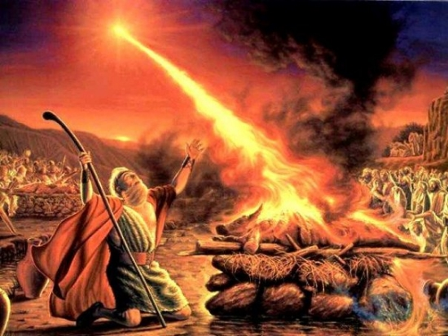

38 Then the fire of the LORD fell, and consumed the burnt sacrifice, and the wood, and the stones, and the dust, and licked up the water that was in the trench.
39 And when all the people saw it, they fell on their faces: and they said, The LORD, he is the God; the LORD, he is the God.

